

University of Puerto Rico at Mayagüez

Department of Computer Science and Engineering

CIIC 4151/INSO 4151 - Capstone

**Final Report: Xchedule**

Developers:

Yetsiel Avilés - 802-14-0524

Carlos J. Ayala - 802-14-0560

Rex Reyes - 802-13-6510

Gabriel Rosario - 802-15-7424

Advisor: Marko Schutz

**Table of Contents**

**Executive Summary** **2**

**Introduction** **3**

**Problem Statement** **3**

**Scope** **4**

**Objectives** **5**

**Summary of Solution** **5**

**Market Analysis** **7**

**Technical Description** **7**

**System Architecture** **7**

Front-end **8**

Back-end **8**

**Modules** **10**

**Entity Relation Diagram** **12**

**Wire-frame for Xchedule’s expected UI** **13**

**Engineering Standards** **14**

**Project Plan** **16**

**Future Work** **17**

**Conclusion** **18**

**References** **18**

# **Executive Summary**

Many businesses that are supposed to work through appointments for their clients do not have an organized way of scheduling them and keep track. In addition, even when certain businesses have a way of sorting their appointments, it turns out to be tedious to schedule each client one by one, on their own. This is where the project involving the elaboration of an appointment scheduler app called “Xchedule” comes in. Through this tool, clients will be able to schedule themselves to specific services based on the available time and restrictions from the corresponding businesses. Hence, “Xchedule” will enable clients to have every different appointment they have through their weekly routines organized. Furthermore, this optimizes the time required for each business to schedule clients one by one, so they can execute their services during working hours effectively. Now, businesses will be able to flow smoothly, executing their corresponding jobs, while having every appointment organized with very little interaction.

“Xchedule” will have various features that are expected to facilitate organization and communication for any business that requires a schedule, and for any client that wants to schedule their appointments, or just constantly keep track of them in case of any changes. Clients will be able to communicate with any business through the app. This helps in situations of emergency or sudden alteration of plans from the business or client. Each user will require a profile inside the app to take advantage of its full usefulness. This will let clients configure their profile effectively to be identified by a business when an appointment has been scheduled. On the other hand, this will let users that own a business have announcements on their profiles, important information regarding the services, the schedule and time available so clients can coordinate their appointments.

# **Introduction**

As technology advances, humans have found ways to automate and optimize just about everything in our lives. From making online payments to reading electronic books, technology has greatly improved our commodity to be able to do almost everything from our phones. However, there is still one aspect that almost all businesses have not tackled just yet. Most businesses people attend frequently do not have an effective scheduling system or don’t have it at all. These businesses keep track of their appointments on physical paper and rarely give you a card as a reminder of the date, and they have to call you to confirm the appointment is still ongoing. This makes it hard for businesses to properly keep track of their pending appointments. Furthermore, for a business owner, it is time-consuming having to schedule a client through the phone, for example, while delivering the service to another client. Each business should focus their working hours on delivering their services without interruptions of any kind, but they still need a way to manage their schedule effectively. A way in which little to none interaction is required while keeping their clients satisfied. These sorts of situations are what this project’s application expects to organize and optimize.

# **Problem Statement**

Our group saw an opportunity to improve business scheduling capabilities through a web application that allows users to schedule themselves remotely as long as the business has the available time or allows the client to schedule an appointment at some specific date. It is important for businesses to execute their services with almost no interruptions while still being able to keep track of their schedule. Hence, the main objective of this project is to help businesses that work with appointments, and their clients, maintain their schedules organized through little interaction while also being able to communicate properly. Furthermore, by allowing clients to schedule themselves to business services, some workload is relieved of businesses by requiring less interaction from them since nowadays most of the appointments can only be scheduled over the phone or in-person and keeping track this way is a lot more tedious. This would also be beneficial for the client since they can accommodate themselves at the most preferable date and time, as well as, giving them automated reminders that would not rely on an actual person calling them to confirm the appointment. Each end, business and client, is being considered for this project. In relation to the scope of our project, businesses not only cover service providers but any other people who perform a job for which an appointment is required or encouraged. Fundamentally, the purpose of this project is to enhance the business-client relationship by optimizing the scheduling procedures and bringing a platform in which both ends can communicate in the most effective way.

# **Scope**

The scope of our project is scheduling management oriented to businesses. This consists of the process of planning, maintaining, developing, controlling, and communicating schedules for time and resources. The strategic benefit of scheduling management is that it will monitor the schedule during its life cycle.

# **Objectives**

Through “Xchedule”, businesses will have a profile in which appointments can be scheduled by clients. A business will be able to postpone or cancel these based on a particular situation or needs. Furthermore, businesses can modify their profile pertinently to better represent their services. Clients will be able to see available times and business operating hours so they can schedule accordingly. Our objective is to implement a web application with features that achieve everything that has been discussed until this point.

The completion of each task is expected to be measured by features through a Gantt Chart. Each group integrant will select different features to work on, but none are excluded from helping on another integrant’s tasks. Ideally, most of the work is done when everyone is reunited for better tracking and testing. In terms of measuring the success of this project, we expect to divide features into fully functional deliverables through which based on the percentage completed in relation to the different progress reviews the team can better evaluate progress.

# **Summary of Solution**

In order to carry out the objectives stated above, a web application is developed as a proof of concept. This increases the effectiveness of the scheduling process for the business, allowing employees that use this application to carry out their regular tasks without being interrupted to schedule potential clients. As for the client perspective, it allows them to carry out the scheduling process for multiple locations and types of business and have them all visible in one place. Thus, minimizing the possibility of scheduling two or more conflicting appointments.

From a business point of view, the value proposition is the ease of seeing all the appointments they have on a daily schedule, with information about the client and the service that the client's request. In addition, your business could compete with other businesses that offer similar services by having this availability to request appointments remotely. From the customer's point of view, the value proposition would be the organization of many of their appointments, in addition to being able to obtain a route to the business to which they request an appointment.

Current solutions exist, however, most of them seem to be proprietary software used by only the company to schedule their own appointments. This causes the end-user to have to go to various websites or applications to schedule their appointments with the different businesses. This is the gap Xchedule will fill. To have one application where you can see your appointments for multiple websites in one single calendar and application. Making it more time efficient for the end-user to manage their appointments, and allowing small businesses that might not have digital appointment managers to be able to upgrade their business in this sense.

This solution could be commercialized by taking this digital approach and providing businesses the tool for a fee in order to appear on the application. For smaller businesses that might want to be more discoverable and grow faster, a “premium” option could be developed to have them appear higher in searches; giving them more visibility for potential clients. The client-side would be free with the possibility of integrating ads to the platform and having an “Ad-Free” version for a fixed cost.

# **Market Analysis**

The market domain includes everyone that owns a business which benefits from having a schedule, and anyone that typically attends these businesses. Possible competitors could be applications such as Google Calendar and Trello, which are softwares that also help having appointments organized through scheduling, but does not allow clients to freely schedule themselves to a specific service, which is why our application would excel in terms of competition. For Xchedule to deploy, a devoted database for the system is required, as well as a medium to host it. Since some personal and business information is stored within the databases, there exists the risk of potential privacy or security faults due to the nature of the application. The website application interface would be this project’s intellectual property, which is to be handled by the respective backend, data access objects and handlers.

# **Technical Description**

## **System Architecture**

The Xchedule system is divided into two main sections, the front-end, and the back-end. The front-end application is to be developed using ReactJS, with Axios to connect to a database application. The back-end of the application consists of the database application and the REST API, these are to be developed using PostgreSQL, Psycopg, and Python Flask respectively.

### *Front-end*

To develop the application’s UI we chose to work with ReactJS, which is a Javascript library for building user interfaces. The ability to create reusable components and manage the current state of the application, which would be changing dynamically, is something that ReactJS is very powerful for. We are accessing the database system implemented at the backend using Axios, which is an easy to use HTTP client that is promise based and that, in the case of asynchronous code, takes advantage of async and await.

### *Back-end*

The database system for the Xchedule application needs to be secure and easy to use. This means working with a good framework for the REST API, so we chose to work with Python Flask. The familiarity with this web application framework is the main reason why we decided to use it. The data in the application will be managed by a relational database system, for which we are going to use PostgreSQL. This was also chosen because of previous experience using the Python Flask-PostgreSQL combination to develop a database system. We are using Psycopg as the PostgreSQL database driver, which was designed for heavily multi-threaded applications that create and destroy lots of cursors and make a large number of concurrent updates and inserts to the database.We also use the Google Maps API, more specifically the Directions API, to show a route from the business’s location to the user’s location, calculating the latitude and longitude coordinates of both locations.

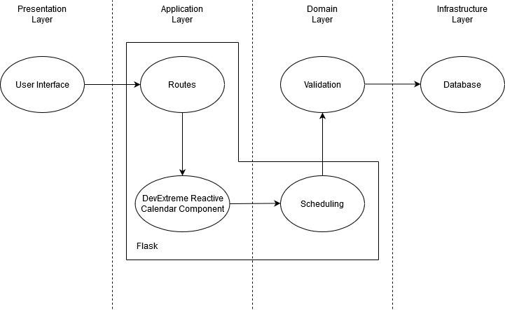

Regarding related works, we started working with Google Calendar implementing it as an API in our application so it could manage schedules and appointments but it did not offer the flexibility we required so we could develop our own work on top. A Google account was needed besides our web application account, which we considered to be too much. Another website that offers appointment scheduling for businesses of every size is AppointmentCore. It offers diverse subscriptions.The cheapest subscription offers a limited number of customers who can use the application, only 1 member per business, and with unlimited appointments. The most expensive subscription offers more features but it is a very high monthly price of approximately $59.95. Hence, we decided to work alternatively with a react calendar component that meets the criteria we expected. It just presents the appointments we fetch from our database, and we do all the work regarding appointment creations, updates, etc. We can also add It serves to project the appointments in an organized way, and allows us to work on top of it, which is exactly what is needed to proceed with the completion of Xchedule. Both client and server will be deployed at Heroku, which is a cloud platform that enables building, running and operating applications entirely in their cloud. All of this will be used to offer a free alternative to future users for scheduling, managing and organizing appointments both from a client perspective and from a business perspective.

## **Modules**

Modules for this project are divided by the pages the web application contains, and some of these are divided by sub-modules. Here’s how they are organized:

* Landing Page (About Us)
  + Mission and Vision
  + Available Businesses
  + Contact Information
* Login Page
  + Login form
  + Sign up form
* Calendar Page
  + Calendar that shows pending appointments
    - Option to edit an appointment
    - Option to cancel an appointment
  + Search engine to find businesses
  + Registered businesses list
  + Frequently visited businesses list
  + Links to the other pages
  + Sign out button
* Business Manager Page
  + Create a business option
    - Only available when no business has been setup yet
    - Transfers to a page in which the user has to fill the corresponding form
  + Change business operating hours
  + See pending appointments
    - Postpone an appointment
    - Approve an appointment
    - Cancel an appointment
  + Manage business announcements
* Business Client Perspective Page
  + Option to schedule an appointment
  + Option to send a direct message
* Appointment Scheduling Page
  + Appointment scheduling form
* Specific Appointment Page
  + Edit appointment
  + Cancel appointment
* Direct Messages Page
  + Message structure that serves like a chat.
* Profile Page
  + Edit personal information
  + Change profile picture

## **Entity Relation Diagram**

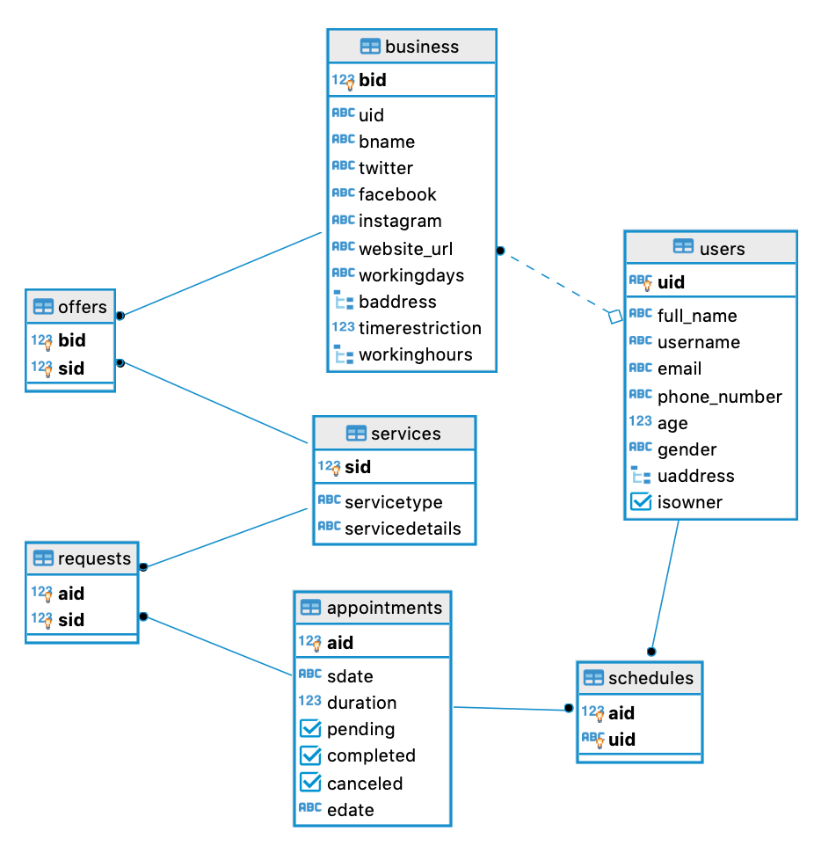

## **Wire-frame for Xchedule’s expected UI**

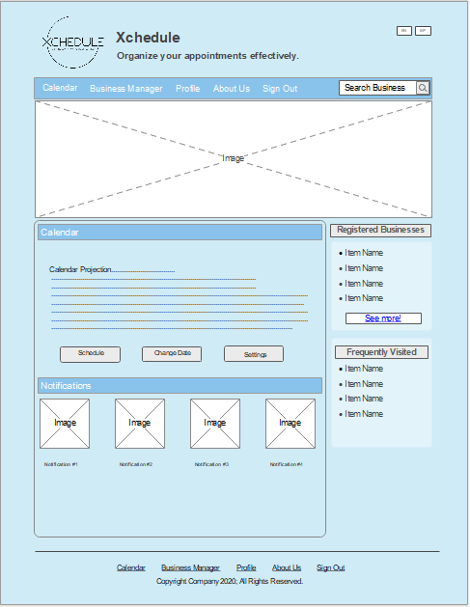

Comparing our designed Wireframe with what ended up being the actual page, it can be seen how they, in essence, look alike. There are obviously details that we did not exactly implement in the same way, as there are also other details that were not integrated at all due to time constraints or simply that they were not very necessary. Fundamentally, the idea we transmitted through the Wireframe design is what we ended up developing, proving it served as a guide at the time of designing the frontend and pertinently configuring the backend so each button and feature could work as they should.

## **Engineering Standards**

Our software to complies with the ACM/IEEE-CS Software Engineering Code of Ethics and Professional Practice, which is available to anyone who is a member of the software engineering profession. As software engineers we ensure to commit to making the analysis, specification, design, development, testing and maintenance of software a beneficial and respected profession, and at the same time, commiting to the health, safety and welfare of the public. We shall adhere to the Eight Principles stated by the Code of Ethics, which state that:

* We shall act consistently with the public interest
* We shall act in a manner that is consistent to the public interest, future clients and employers.
* We shall ensure that the modifications of our product meet with the highest professional standards possible.
* We shall maintain independence and integrity in our professional judgement.
* We shall promote and subscribe to an ethical approach to the management of software maintenance and development.
* We shall advance the reputation and integrity of the profession consistent with the public interest.
* We shall be supportive and fair to our colleagues.
* We shall participate in lifelong learning with regards to our profession.

We will also strive to comply with the ACM Code of Ethics and Professional Conduct, which is designed to guide and inspire the ethical conduct of all computing professionals and anyone who uses computing technology in an impactful way. It serves as a basis for remediation when violations occur and it includes statements of responsibility, based on the understanding that the primary consideration is the public good. It is divided into 4 sections. Section 1 outlines fundamental ethical principles that form the basis, specifying that we as aspiring computing professionals must contribute to society and to human well-being, acknowledging that all people are stakeholders in computing. We must avoid harm, be honest and trustworthy, be fair and take no action to discriminate, respect privacy, and honor confidentiality. We must respect the work required to produce new ideas, inventions, creative works, and computing artifacts. Section 2 addresses additional, more specific considerations of professional responsibility, where we as aspiring computing professionals must strive to achieve high quality in both the processes and products of professional work. We must ensure that we maintain high standards of professional competence, conduct, and ethical practice. We must know and respect existing rules pertaining to professional work. Accept and provide appropriate professional review, perform only in areas of competence, give comprehensive and thorough evaluations of computer systems and their impacts, including analysis of possible risks. As aspiring computing professionals, we must foster public awareness and understanding of computing, related technologies, and their consequences, access computing and communication resources only when authorized or when compelled by the public good, and design and implement systems that are robustly and usably secure. Section 3 guides individuals who have a leadership role, whether in the workplace or in a volunteer professional capacity, where we as aspiring computing professionals, especially if we act as a group leader in any case, must ensure that the public good is the central concern during all professional computing work. We must comply to articulate, encourage acceptance of, and evaluate fulfillment of social responsibilities by members of the organization or group. Managing personnel and resources to enhance the quality of working life is part of our responsibility, as well as creating opportunities for members of the organization or group to grow as professionals. We must recognize and take special care of systems that become integrated into the infrastructure of society. Section 4 gives principles involving compliance with commitment to ethical conduct. As aspiring computing professionals, we must uphold, promote, and respect the principles of the ACM Code of Ethics, and treat violations of it as inconsistent with membership in the ACM.

# **Project Plan**

* Milestones
  + Phase I Progress Review
    - Deadline – 03/30/2020
  + Phase 2 Progress Review
    - Deadline – 05/06/2020
  + Final Project Review and Demo
    - Deadline – 05/27/2020
* Deliverables
  + Project Proposal
  + Prototype Demonstration / Midterm Report
  + Fully Functional Application
  + Final Project Report
  + Final Demo and Presentation
* Team Organization
  + Each team member was responsible for the modules assigned. This does not exclude other team members from helping. Most of the work was done collaboratively for the purpose of efficiently merging everything.
  + In terms of leadership, everyone took equal responsibilities and initiatives regarding when to follow up and push to meet pertinently with pending deadlines. Every single member worked together before and, based on this, a fluent and dynamic work environment is expected for this project.
* Collaboration Tools
  + Google Drive
  + Github
  + Trello
  + Google Meets
  + Discord
  + Riot

# **Future Work**

To continue working in the future with our application is something that can happen without problems. Obviously, we worked on what could be implemented during one semester, but there are many features and details that would open the market for our web application. For example, implementing ads so different businesses can be sponsored, in addition of enabling users to be included as owners of more than 1 business in their accounts. It would be a benefit to create a mobile application that is derived from our web application, to facilitate its use and even encourage people to use it more. There still exist a lot more opportunities regarding the application, even though it already meets with the objective we had since the beginning. All the code is pertinently documented so any person that might work with Xchedule in the future can find its way fluently.

There are plenty of great features that could be added to the current version of the application also. These include the ability of receiving notifications when an appointment has been processed, or postponed by the business owner, for example. Xchedule could be also capable of supporting files uploaded by each user so, for example, people could upload their medical records privately so only their doctor through their respective business could have it available beforehand, for any analysis or previous evaluation before an appointment takes place. There obviously are many more cool features that could be implemented, but the ones mentioned where the ones we mostly considered while working with the project.

# **Conclusion**

As our project regarding the development of Xchedule concludes, we can say every essential objective we established at the beginning of this journey was met. The application does what it was originally intended to do, helps avery business and respective clients have every appointment organized efficiently, allowing clients to schedule themselves on each service they would be needing so the business does not have to constantly interact with the application and continue executing its work. Nonetheless, business have the option of postponing appointments meeting their particular needs in a sudden, urgent situation. Evidently, there exist posible features that can be added to the application, which could be worked with in future work, but, as of today, it meets with the fundamental features we wanted to implement with priority by the end of this unusual semester.

Xchedule is very simple, easy to use application for any kind of potential user. Hence, a fully functional application has been delivered per expectations. As a group, we used many of the concepts learned throughout our bachelor's race, and skills gathered from our individual past experiences. We feel accomplished with what we achieved. This concludes our Capstone project and work for this semester. The application is currently being hosted through the following link: <https://xchedule-uprm.herokuapp.com/login>

# **References**

[1] Trello. (n.d.). Retrieved February 18, 2020, from https://trello.com/

[2] Google Calendar (n.d.). Retrieved February 18, 2020, from https://calendar.google.com/calendar/r?pli=1

[3] Björner Dines. *Software Engineering: Domain, Requirements, and Software Design*. Vol. 3, Springer, 2006.

[4] Don Gotterbarn, Keith Miller, and Simon Rogerson. 1997. Software engineering code of ethics. *Commun. ACM* 40, 11 (November 1997), 110-118.

[5] React Scheduler. (n.d.). Retrieved April 16, 2020, from https://devexpress.github.io/devextreme-reactive/react/scheduler/docs/guides/getting-started/

[6] *Google Maps Platform*. [Online]. Available: https://developers.google.com/maps/documentation/directions/start. [Accessed: 21-May-2020].

[7] “psycopg,” *Psycopg*. [Online]. Available: https://www.psycopg.org/. [Accessed: 21-May-2020].

[8] C. Vasile, “How to use Axios with React (Everything you need to know),” *DesignRevision*, 09-Feb-2019. [Online]. Available: https://designrevision.com/react-axios/. [Accessed: 21-May-2020].

[9] “Small Business Appointment Scheduling,” *AppointmentCare*, 14-Jun-2018. [Online]. Available: https://www.appointmentcare.com/small-business-appointment-scheduling/?utm_source=capterra. [Accessed: 21-May-2020].

[10] “React-A JavaScript library for building user interfaces,” *React*. [Online]. Available: https://reactjs.org/. [Accessed: 21-May-2020].

[11] “Code of Ethics,” *ACM Ethics*, 23-Sep-2019. [Online]. Available: http://ethics.acm.org/code-of-ethics/. [Accessed: 21-May-2020].

[12] “Heroku,” *Cloud Application Platform*. [Online]. Available: https://www.heroku.com/. [Accessed: 21-May-2020].

[13] “Welcome to Flask,” *Welcome to Flask - Flask Documentation (1.1.x)*. [Online]. Available: https://flask.palletsprojects.com/en/1.1.x/. [Accessed: 21-May-2020].